FINANCIALS AND STATISTICAL MACROECONOMIC DATA.

**- Financials:**

1) Merck (orange) performance in return % compared to Abbvie (green), Pfizer (blue) and J&J (black)

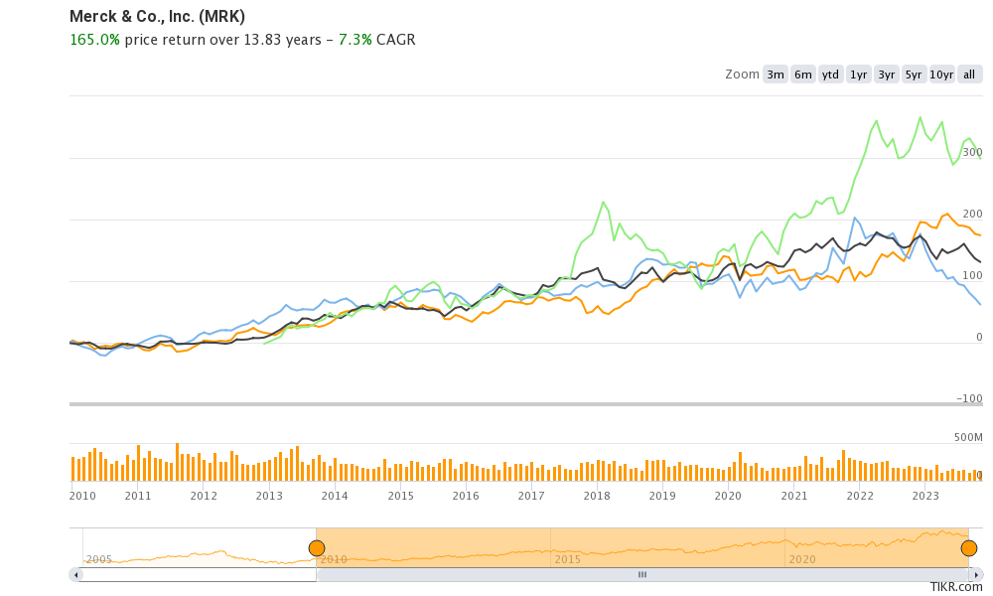

2) Merck performance compared to an index of competitors and the SP500 since 2017.

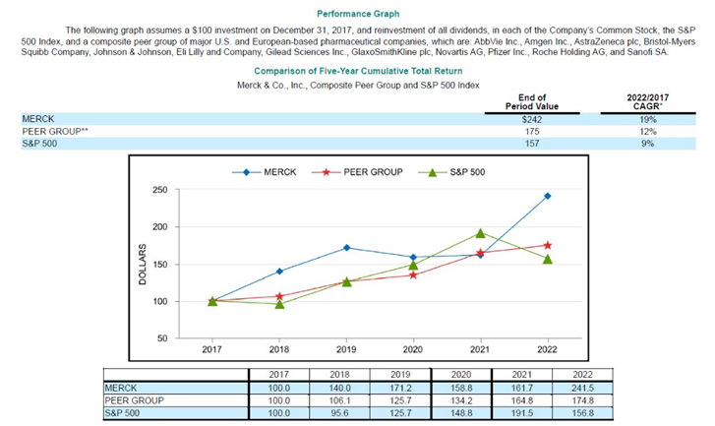

3) Net income development since 2015-2022.

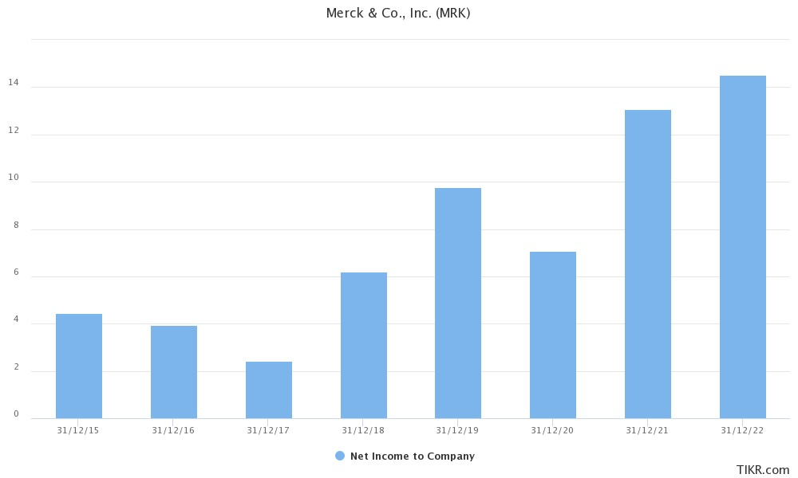

4) ROE performance compared to competitors (PFE and JNJ) since 2015-2022.

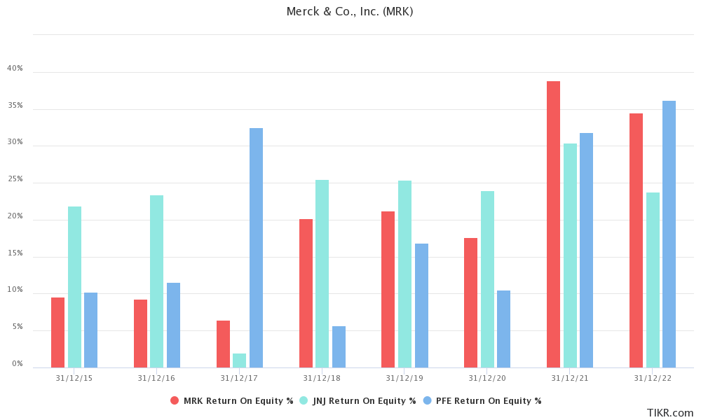

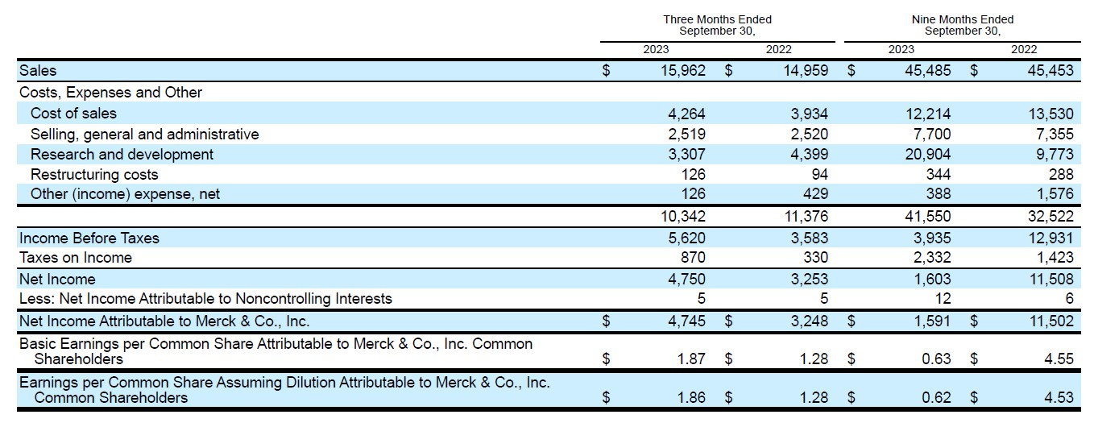5) Income Statement of 3Q of 2023: As we can observe, Merck maintains its total sales stable, while the rest of the competitors have a huge drop (Pfizer goes from $77 to $45 billion comparing the first 3Qs of 2022 and 2023). The unusual drop in our ROE and ROS is due to the purchase of Prometheus and Imago Biosciences, which account for around $12 billion.

6) Merck R&D expenses compared to competitors (PFE and JNJ).

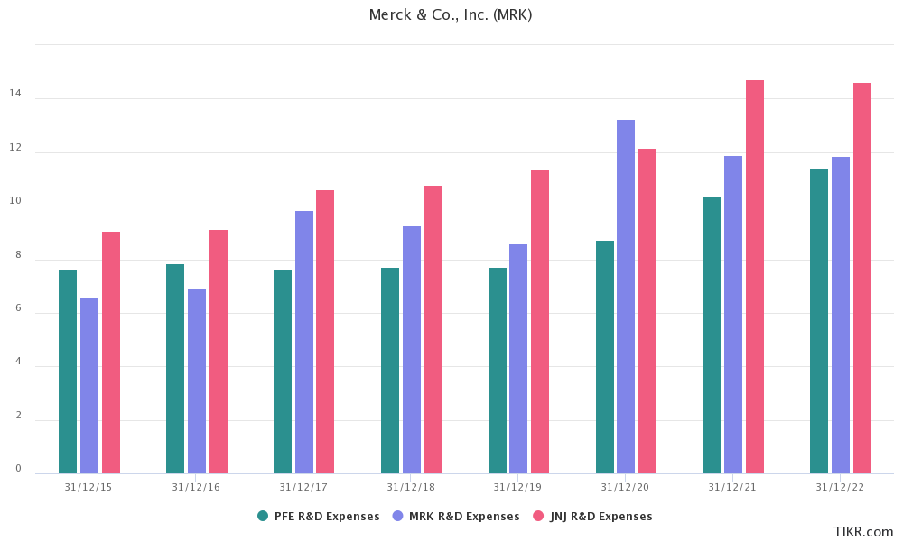

7) BRICS GDP expected growth until 2028:

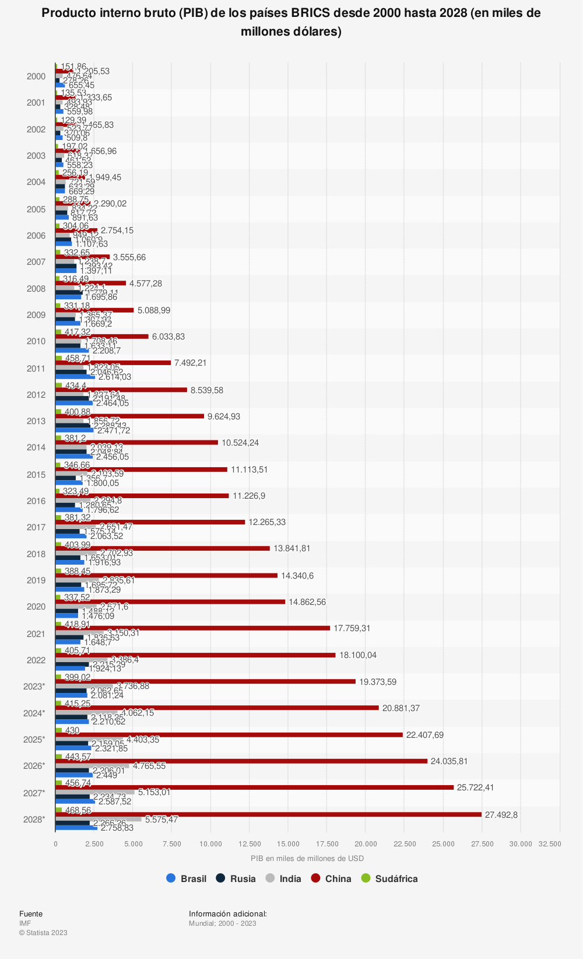

8) Chinese GDP expected and past growth 1985-2027).

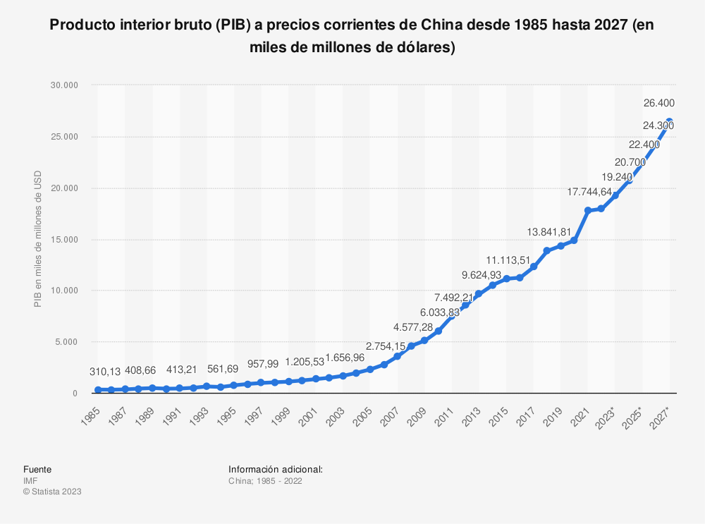

9) GDP 2023 and forecast for 2030.

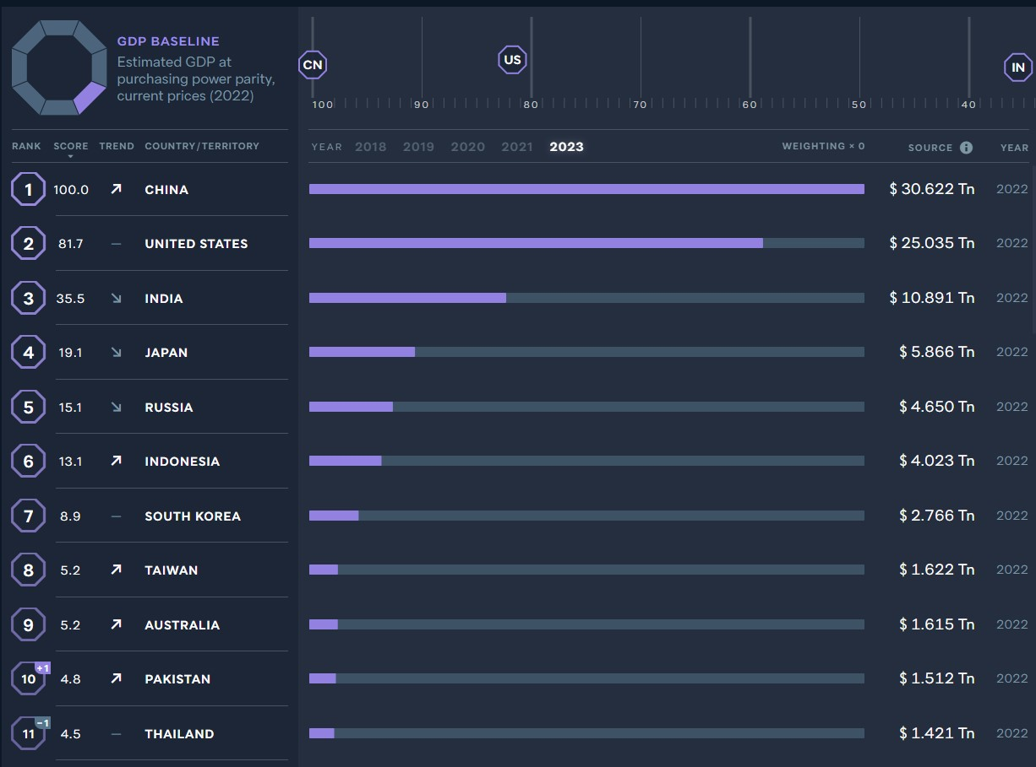

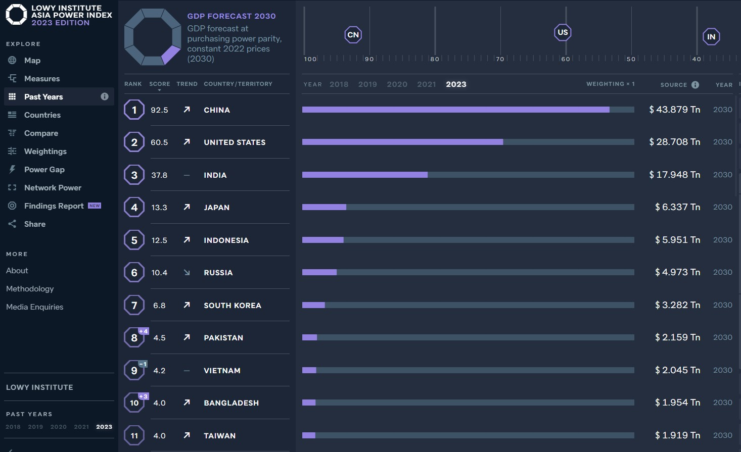

10) Incidence of acute myocardial infarction with concomitant metabolic diseases and risk factors in Singapore.

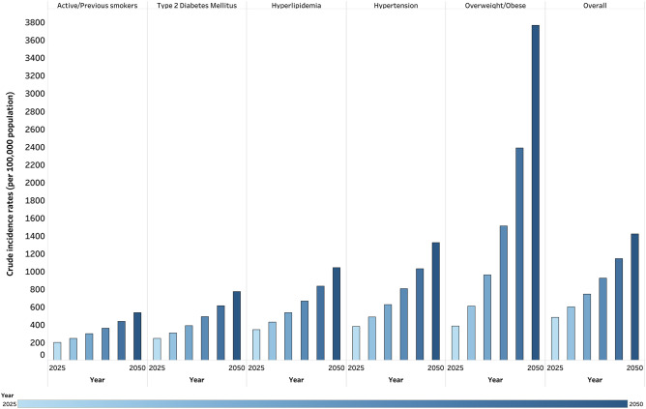

11) Graphs comparing the trend of different diseases until 2050.

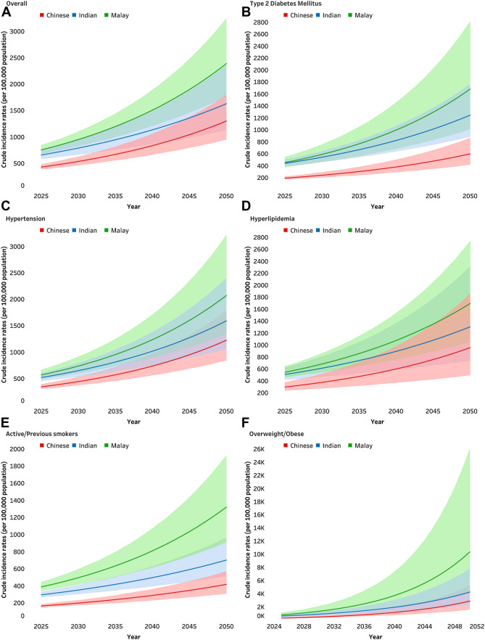

12) <https://www.thelancet.com/journals/lanwpc/article/PIIS2666-6065(23)00121-9/fulltext>.

Similar to our population estimates, predictions from the general United States (U.S.) population reported that nearly 1 in 2 adults will be obese by 2030: Ward Z.J.Bleich S.N. Cradock A.L.et al. Projected U.S. State-level prevalence of adult obesity and severe obesity. N Engl J Med. 2019; 381: 2440-2450

The incidence of AMI is projected to continue rising sharply in the coming decades and will be paralleled by worsening metabolic disease trends. The AMI incidence is expected to increase by 194% from 2025 to 2050, with obesity ratios escalating up to 294%.

13)Metabolic diseases evolution: <https://www.ncbi.nlm.nih.gov/pmc/articles/PMC5866840/>.

Global prevalence of diabetes is 8.8% (415 m) as of 2015 and is expected to increase to 10.4% (642 m) by 2040. The highest prevalence of diabetes was in North American and Caribbean region (11.5%). Over half of all people with diabetes were living in Southeast Asia and Western Pacific region. Prevalence is still relatively low in Africa region. But in next 25 years, some of the highest growth rate in diabetes is expected to be in sub-Saharan Africa and Middle East/North Africa (141 and 104%, respectively). In other words, over a billion people in the world are now affected with metabolic syndrome.